Math Circle Problem Set 3. Name:

Problem 3.1: Last time we played the game where there are 20 stones; on your turn you can take 1, 2, or 3 stones; and whoever takes the last stone wins. We found that the copying strategy was pretty good. We also found that if it’s your turn and there are 4 stones left, the other person can always win no matter what you do.

Make two lists: one list for the winning numbers (where there is a strategy that lets you win) and another list for the losing numbers (where the other person can always win no matter what you do. 4 is a losing number, and that means 5 is a losing number because you can take 1 stone.
Winning numbers: Losing numbers:
4 5

Problem 3.2: If there are 23 stones at the start of the game, is it better for you to go first or second? What should be your first move?

What if there are 24 stones?

Problem 3.3: Now Mr. Five wants to play the game, but his favorite number is five. So he changes the rules of the game - now you can take 1, 2, 3, 4, or 5 stones.

What is the pattern of the winning and losing numbers for the new game?

Problem 3.4: Below are two ways to build a hexagon of the same size.
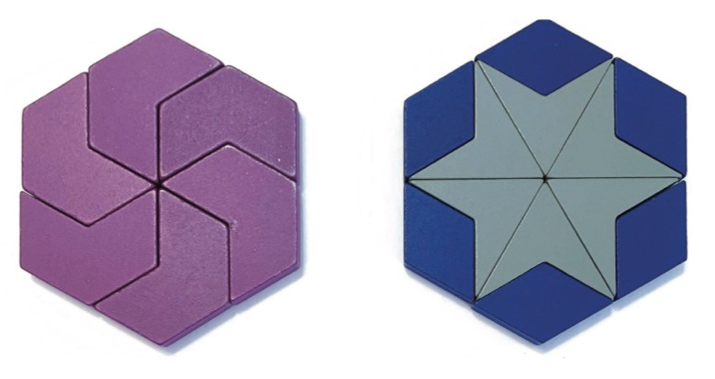
How many other ways can you find to make the same hexagon? Put them in the middle of the table for the class to compare.

Problem 3.5: Make a shape from the tiles with reflection symmetry. Draw it below.

Problem 3.6: Make a shape from the tiles with rotational symmetry. Draw it below. How many times can your shape be rotated?

Problem 3.7: Can you make a shape with two lines of reflection symmetry? Draw it below.

Problem 3.8: Help Ben the bee put the numbers 1, 2, 3, 4, 5, 6, and 7 into the beehive so that each line through the middle has the same total.
